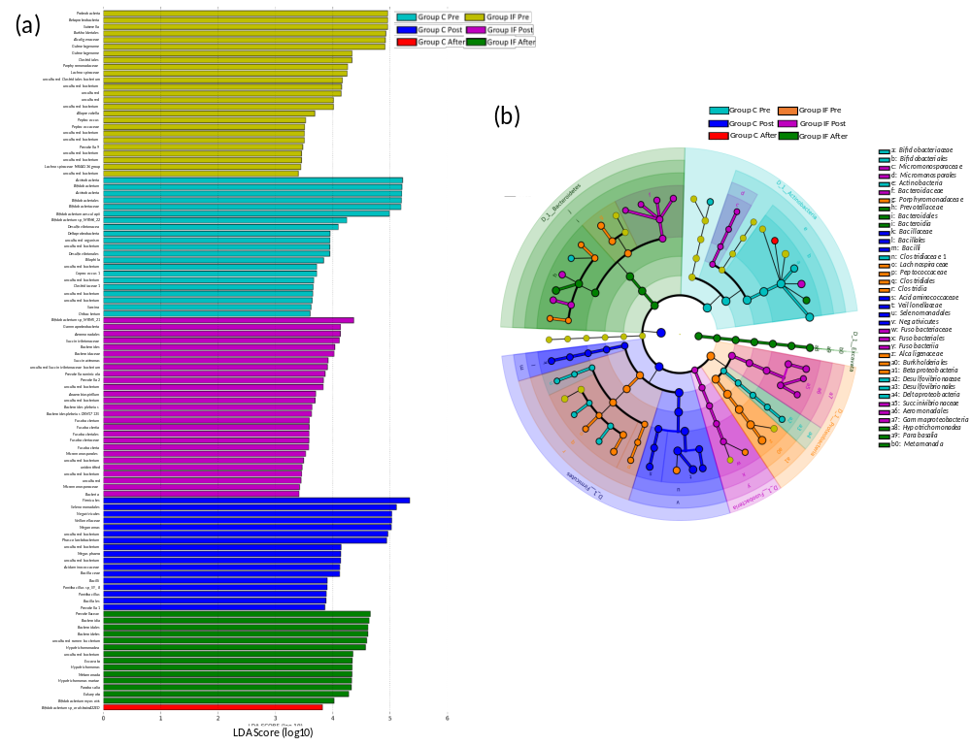
Figure 4. LEfSe characterization of the dominant microbial taxa according to the experimental conditions of each group. (a) Ranked lists of microbes by effect size for Groups C and IF in all three conditions. (b) Cladogram based on the ranked list in (a) to visualize the relationships between the experimental conditions and the phylogenetic relationships among the microbes.

